Hardware setup:
- Raspberry Pi 3, Raspberry Pi OS, accessed via [SSH]
- 4x DC gear motors (TT motors), one per wheel (front-left, rear-left, front-right, rear-right)
- 2x TB6612FNG motor driver boards
- Driver 1 controls LEFT side: front-left motor on Channel A, rear-left motor on Channel B
- Driver 2 controls RIGHT side: front-right motor on Channel A, rear-right motor on Channel B
- Motor power: 2x LiIon battery (3.4V each)→ VM and GND on both drivers
- Logic power: Pi 3.3V → VCC on both drivers
- Common ground: battery GND, both drivers' GND, and Pi GND all tied together

GPIO pin assignments:
Front-Right(+) ──→ AO1 (Driver 2)
Front-Right(−) ──→ AO2 (Driver 2)

Rear-Right(+) ──→ BO1 (Driver 2)
Rear-Right(−) ──→ BO2 (Driver 2)

Front-Left(+) ──→ AO1
Front-Left(−) ──→ AO2

Rear-Left(+) ──→ BO1
Rear-Left(−) ──→ BO2
Battery = VM
Rasp pi 3.3 = VCC

Signal | Driver 1 (left) | Driver 2 (right)
STBY | GPIO21 (shared) | GPIO21 (shared) |
PWMA | GPIO12 | GPIO18 |
AIN1 | GPIO5 | GPIO23 |
AIN2 | GPIO6 | GPIO24 |

PWMB | GPIO13 | GPIO19 |
BIN1 | GPIO16 | GPIO25 |
BIN2 | GPIO20 | GPIO26 |

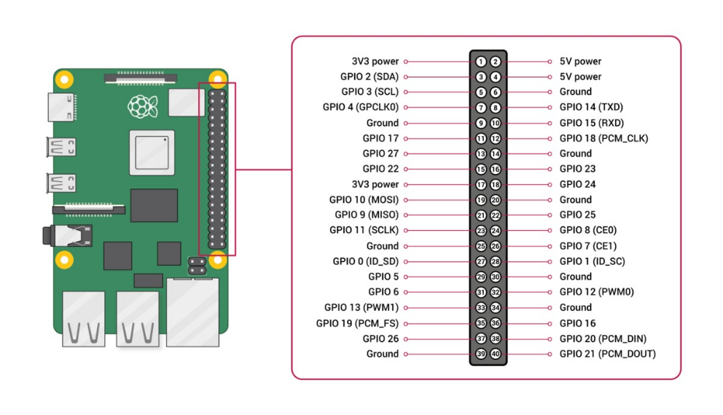

Channel A on each driver = front motor (left or right side)
Channel B on each driver = rear motor (left or right side)
Enables STBY (sets HIGH)
MPU6050 IMU — planned pins, not wired yet:
MPU6050 | Connects to
VCC | Pi 3.3V
GND | Pi GND
SCL | GPIO3
SDA | GPIO2

Wheel encoders
- GPIO4 → right-side encoder OUT
- GPIO8 → left-side encoder OUT

Ultrasonic sensors (3x HC-SR04, shared TRIG line)
Sensor | TRIG | ECHO | VCC | GND
Front | GPIO27 (shared) | GPIO17 (via voltage divider) | Pi 5V | Common GND
Left | GPIO27 (shared) | GPIO22 (via voltage divider) | Pi 5V | Common GND
Right | GPIO27 (shared) | GPIO7 (via voltage divider) | Pi 5V | Common GND

